 | Hemispheres |  | Using the equator and prime meridian, we can divide the world into four hemispheres, north, south, east, and west.
 |  |  | Western Hemisphere
 |  |  | Eastern Hemisphere
 |  |  | Northern Hemisphere
 |  |  | Southern Hemisphere
 | 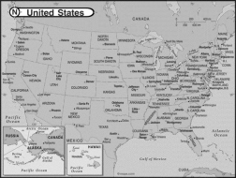 |  | Political Map – shows how people have divided places on Earth
 | 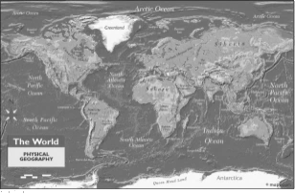 |  | Physical Map – shows what the surface of Earth naturally looks like.
 | 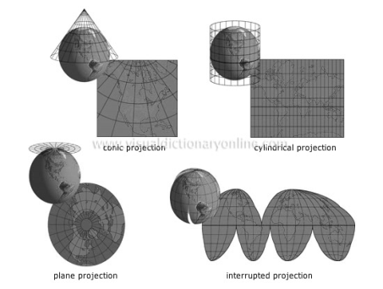 |  | Map Projections- different ways to show the Earth.

