Map Skills | Title |  | Tells you what the map is about.
 | Map Key/Legend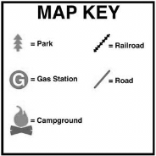 |  | An area on the map that shows you what each symbol represents.
 | 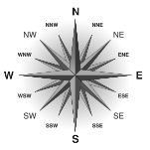  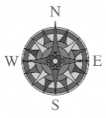  Compass  Rose |  | A symbol on a map which indicates the directions for a map.
 | Scale 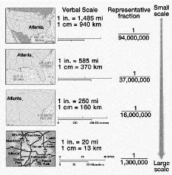 |  | Section of the map that shows how much smaller the map is compared to the real size.
 | Cardinal Directions |  | North, South, East West
 | Intermediate Directions |  | 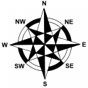  Northeast, Southeast, Northwest, Southwest
 | 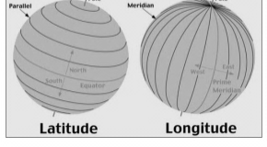  Grid |  | Latitude and Longitude lines form a map grid.
 | Latitude Lines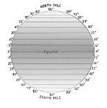 |  | Imaginary lines circle that circle the globe running East to West.
 | 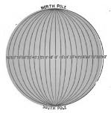  Longitude Lines |  | Imaginary lines that circle the globe running North to South.
 | 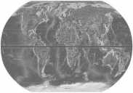  Equator |  | Zero degree line of latitude that separates the Northern hemisphere from the Southern Hemisphere.
 | 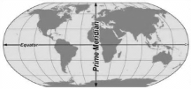  Prime  Meridian |  | Zero degree line of longitude that separates the eastern and western hemisphere.

